Asaf Betman I.D. 034087122
Dror Helper I.D. 034354712

Software Testing
Homework Assignment (bug)

Purpose
The attached program designed to be a part of a benchmark that test new processors performance.
The program’s part is to run multiple threads, each performing random division actions.
Another part of the benchmark measures the processor properties while the program is running.

Description
This program demonstrates a multi-thread bug:
Each thread is doing some work using thread->run
Only MAXTHREADS number of threads is allowed to run in the same time

- Before starting to work the thread:
- Check if number of running threads in lower then max working threads allowed.
- Increase the "working threads" counter.

- After finishing work the thread decrease the counter

Parameters
The program can receive up to two parameters:
- Log File to which to write a log to.
- Occurrence of the bug (lot/medium/little).

The default values are “result.txt” and medium.

The Bug
As described above each thread increase the counter of currently running thread by one (in initWork line 202).
In case of exiting by exception (line 210 may cause division by zero) the thread doesn't decrease (in finalizeWork line 213) the counter and less thread are able to run.
This may even cause a deadlock in case MAXWORKERS threads exited by exception.
The bug pattern shown here is of “Blocking Critical Section” type which is caused by exiting the critical section without releasing it and my cause a deadlock in some cases.

Dictionary
The program’s output file may contain one of the tuples:

< ThreadTest, 0, none>
No bug was encountered and program exited without any errors.

< ThreadTest, number, BLOCKING_CRITICAL_SECTION>
number of thread didn’t exit the critical section correctly causing a blocking critical section error.
<ThreadTest, DEADLOCK, BLOCKING_CRITICAL_SECTION>
maxthreads of threads didn’t exit the critical section correctly causing a deadlock.

RaceFinder
The program was instrumented and run using RaceFinder with several heuristics in medium bug appearance mode (little does not show the bug at all and lot shows the bug all the time).
The following chart describes the results of the program using the different RaceFinder heuristics:
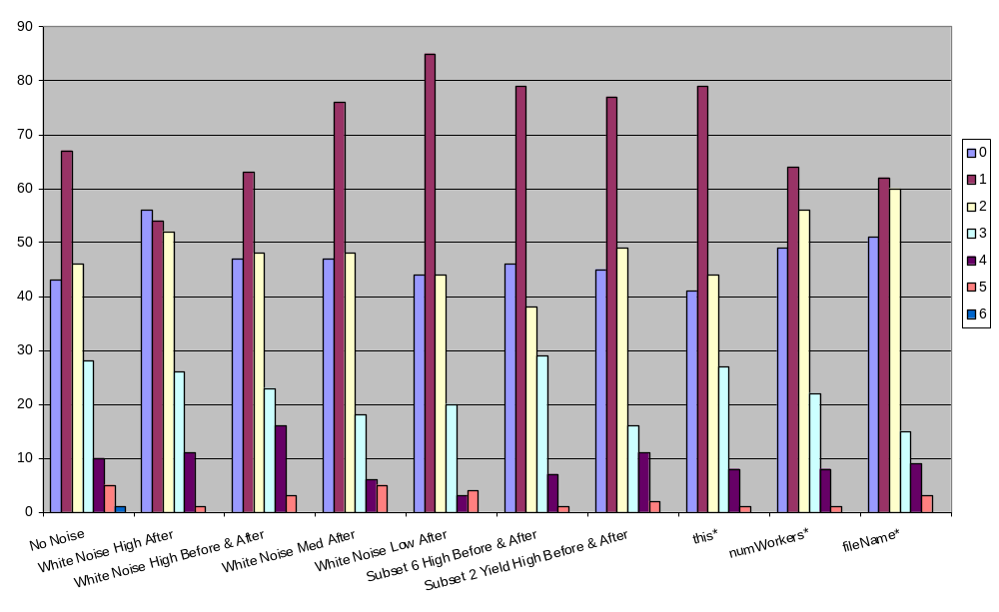
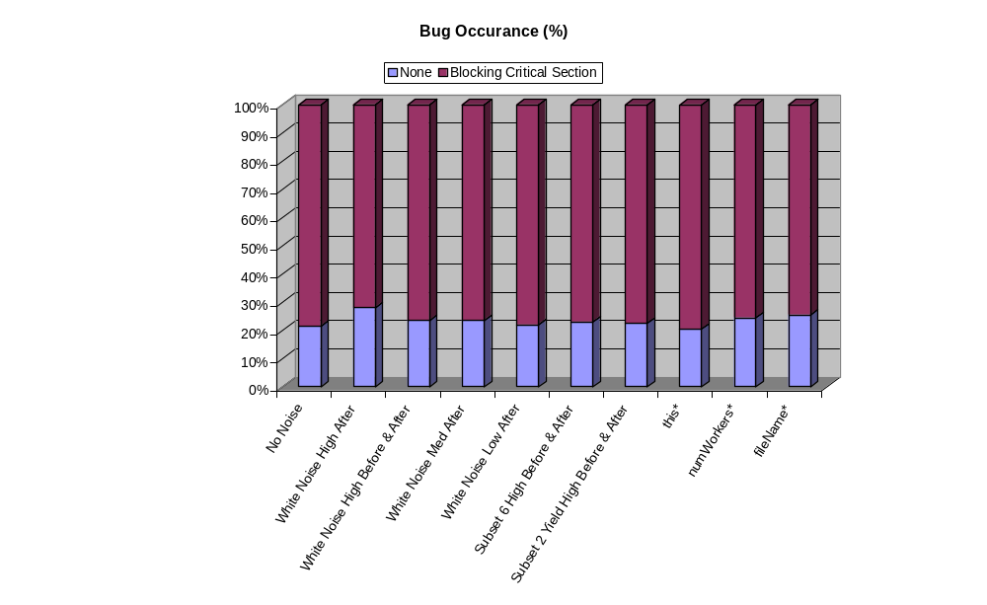
We notice that the results are around 40-50 runs without any bug showing in every 200 runs (about 20%-25%), and the heuristics doesn't seems to change the appearance rate of the bug, (for example in every run 2 occurrences of the bug are the most likely to appear).
This can be explained by the fact that the bug is not influenced by the ordering of the worker threads.
The bug is caused because the program's exception handling mechanism doesn't free used resource while exiting, (in our case a counter).
And the causes of the bug (exceptions) are triggered regardless of the threads concurrency (we "accidentally" divide by 0).
However we can see that RaceFinder managed to mark numWorkers as one of the problematic variables due to the fact that it is accessed by all the threads, and in fact this variable is the resource that we fail to free when the program exit by exception.

